Exam 2 (Modules 3 and 4) Study Guide
Test is 10/4!

Answer these questions on your own paper.

Biomolecules
- The pH scale goes by factors of _______.
- A substance with a pH of 10 is _____ times more ___________ than a solution with a pH of 8
- List all of the polymers we learned in class and identify their monomers.
- List ALL of the examples of carbohydrates talked about in the powerpoint.
- List ALL of the examples of lipids talked about in the powerpoint.
- List all of the functions of proteins
- Write out the Protein levels of organization.
- Which 2 foods, when eaten together, give us all of the essential amino acids?
- What are prions?

Cell Structure
- List all of the organelles and ALL of their functions.
- Complete the following Venn Diagram
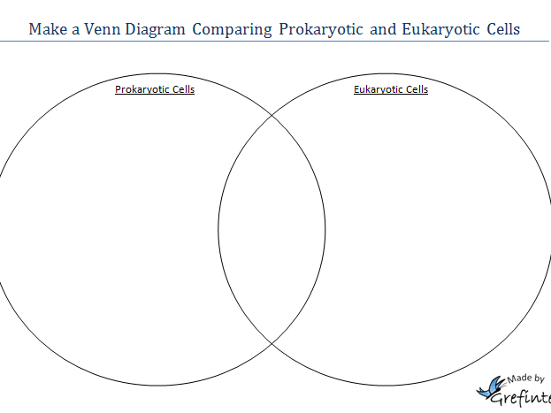

- Your mitochondrial DNA comes from your ________________
- Understand cell specialization. For example, a muscle cell would need lots of energy and would have a lot of ___________________.
- List ALL of the evidence supporting The Endosymbiotic Theory
- Label the microscope used for each of the following images:
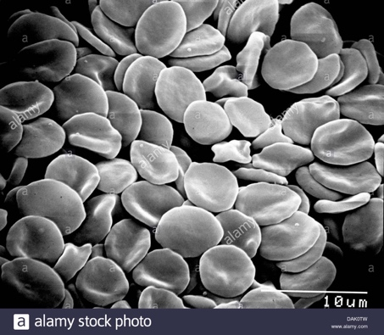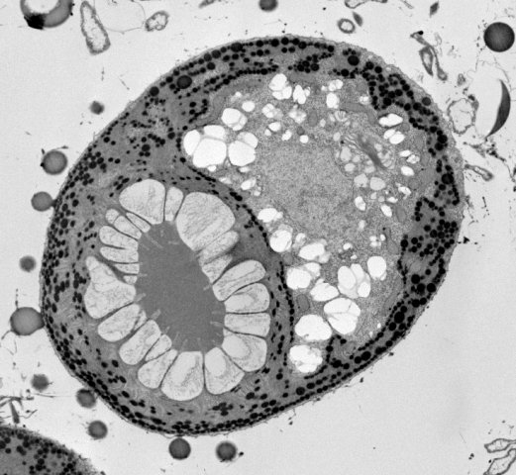

Cell Membrane and Transport
- What are the causes of cystic fibrosis, Tay Sachs, and hypercholesterolemia?
- Label the types of transport occurring in the figure below
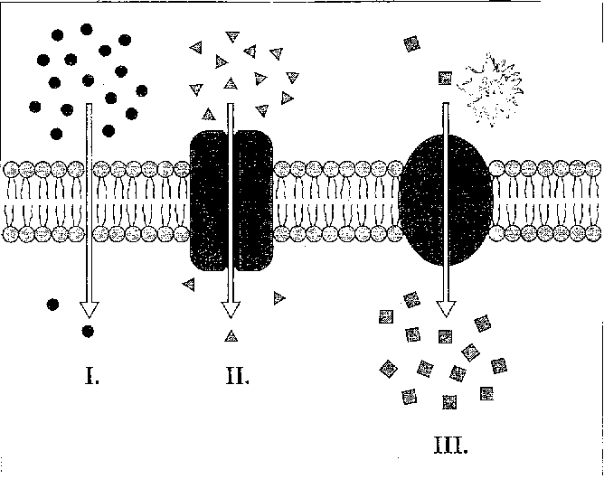

- How does temperature affect membranes? How is a membrane at a high temperature different from a membrane at a low temperature?

DNA Structure
- Explain the structure of DNA. What type of bond holds the 2 strands together? What bases bind to one another.
- What is Chargoff’s rule?
- Define the following: gene, chromosome, nucleotide, codon. Put them in order from largest to smallest.

Protein Synthesis
- Fill in the blanks : _________ to ____________to protein
- What proportion of a cell’s DNA codes for proteins?
- What is the ENCODE project?

- Describe the process of transcription in detail including location and enzyme.
- What causes different types of cells to produce different proteins?
- True or false: The genetic code used to translate proteins is the same in all organisms
- What amino acid would the codon GGG code for?

- Describe the process of translation- include location and enzymes
- Draw a transfer RNA molecule with an anticodon of AAA. What amino acid is attached at the other end?

- The DNA sequence GTC translates to what amino acid? (Hint: Don’t forget the mRNA step)
- What are introns?

