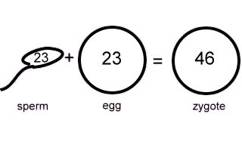
Meiosis Guided Notes:

Meiosis:
- Meiosis is form of cell division by which
- Meiosis is _______________ reproduction
- ______ divisions (meiosis I and Meiosis II)

Meiosis:

- Male ____________________________
  - Sperm
- Female __________________________
  - Egg or ova

Spermatogenesis:
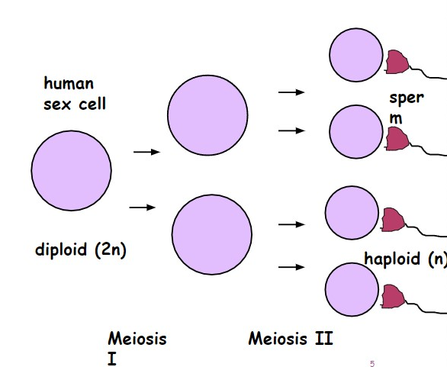

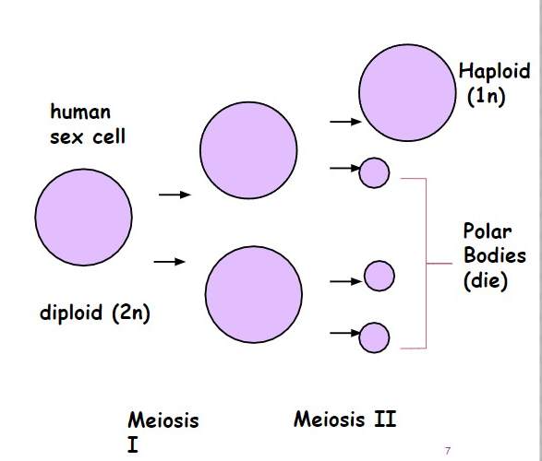
Oogenesis:

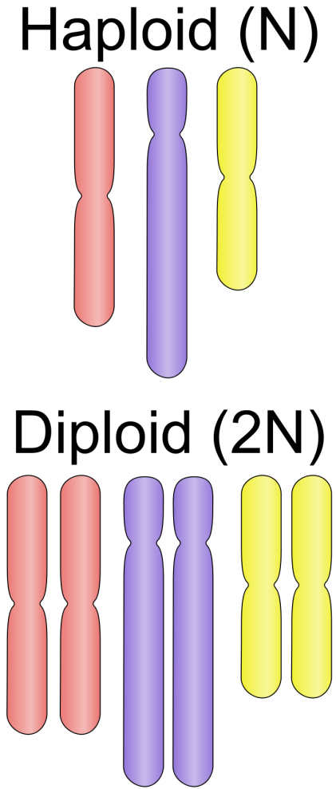
Haploid vs. Diploid Cells

Haploid -

Diploid -

Meiosis I (4 phases)

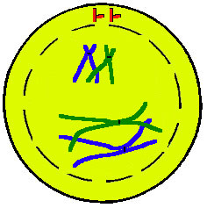
- Cell Division that …
- Four phases:

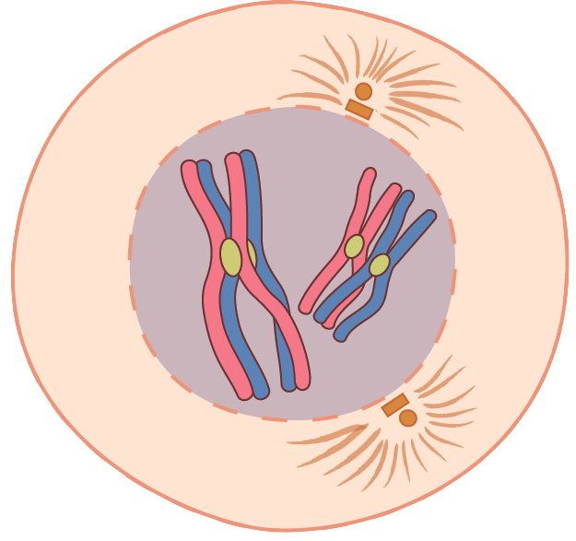
Prophase I:

- Same as mitosis prophase but ____________________ ______________________ pair up
- Tetrad is _______ _____________________________ or _______ ________________ (two sets of sister chromatids)

Crossing over:
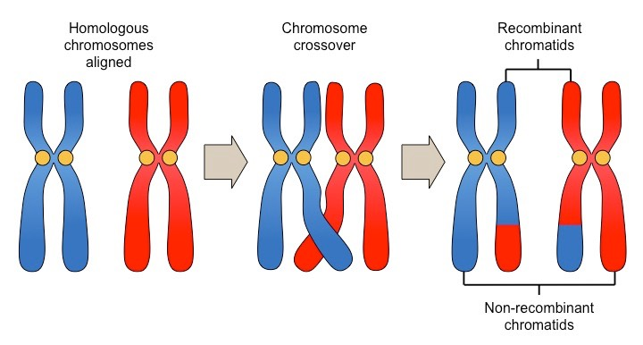

Sex Chromosomes:
- Female __ __
- Male __ __

Metaphase I

Anaphase I
- _______________ separate

Telophase I

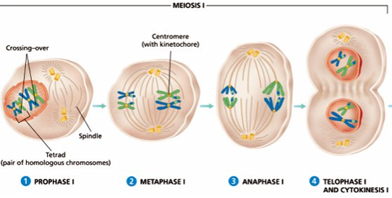

Meiosis II:

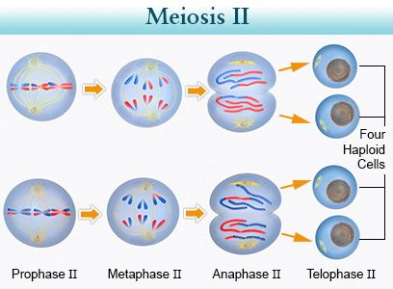

Question;
- A cell containing 20 chromosomes (diploid) at the beginning of meiosis would, at its completion, produce cells containing how many chromosomes?

Goal of Meiosis is to…

