**Evolution Review Sheet**

**Section 1 Charles Darwin and Other Scientists**

* 1. Darwin’s ship is named _____________________.
  2. Darwin stopped at __________________ on his trip around the world and made many of his observations.
  3. Darwin noticed the finches from different islands had different shaped beaks because ______________________________________________________________________________.
  4. After his trip, Darwin concluded ______________________________________________________.
  5. ____________ and ____________ studied geology and determined the Earth was millions of years old.
  6. ______________ believed organisms acquired traits through use or disuse and passed them to offspring.
  7. Darwin’s book is called __________________________.
  8. What is **artificial selection**?
  9. How is artificial selection different than natural selection?

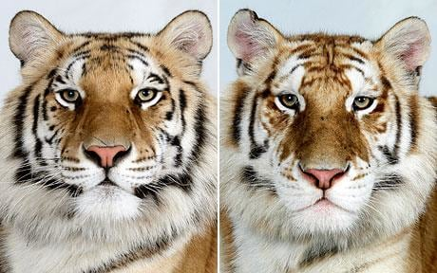

**Section 2-3 Natural Selection, Evidence for Evolution**

* 1. What does **variation** mean?
  2. Name one variation between the two tigers.
  3. What is another phrase for natural selection?
  4. What is an **adaptation**?
  5. Explain an adaptation that a bird might have to help it reach a food source.
  6. Explain how camouflage can be an adaptation.
  7. Where or how does an organism get an adaptation?
  8. What does it mean for an animal to be “fit” or have a high **fitness**?
  9. Before the industrial revolution, why were the grey peppered moths considered more “fit?”
  10. What does **evolution** mean?
  11. What is the name of the process or “mechanism” that carries out evolution?
  12. Can an individual organism evolve in its own lifetime? Why?
  13. Can a species evolve generation to generation? Why?
  14. **Natural selection** has 4 parts: explain all four!
  15. Why is the fossil record considered evidence for evolution?
  16. What is a **homologous structure**? Give an example.
  17. What is a **vestigial structure**? Give an example.
  18. How does **embryology** provide evidence for evolution?

**Section 5 Evolution as Genetic Change**

* 1. An average weight baby is the most likely to survive. This is ___________________ selection.
  2. Longer bird beaks gather food better. This is ___________________ selection.
  3. Both small and large bird beaks are well adapted to survive. This is _________________ selection.
  4. What type of selection can result in 2 new subgroups? _________________________
  5. What type of selection favors the average individual? _________________________
  6. What type of selection favors one extreme trait over the middle and other end? _______________
  7. Label each graph *disruptive, directional,* or *stabilizing selection.* Then draw the curve for the new graph!

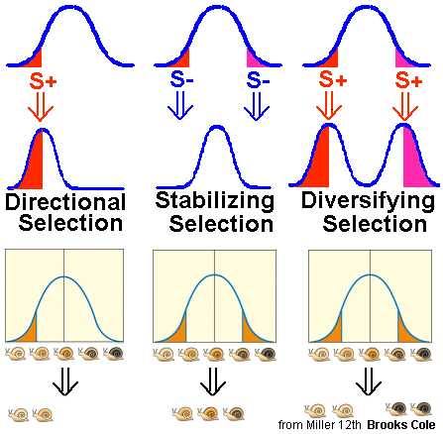

**Section 6 - Speciation**

* 1. What is speciation? ____________________________________________________
  2. What is reproductive isolation? _____________________________________________