Blood Types and the Immune System

Table 1. Blood Types and the Antigens That Cause Them.
Blood Type | Red Blood Cell diagram | Recognized by:
 |  | Anti-A Antiserum? | Anti-B Antiserum?
A | 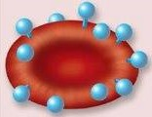 | Yes | No
B | 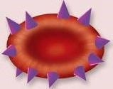 | No | Yes
AB | 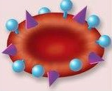 | Yes | Yes
O | 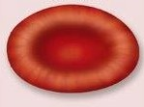 | No | No

Table 2. Compatibility of Blood Types.
Patient’s Blood Type | Patient’s Blood Contains Antigens | Can Receive Blood from Donors Who Are
A+ | A, Rh | A+, A-, O+, O-
A- | A only | A-, O-
B+ | B, Rh | B+, B-, O+, O-
B- | B only | B-, O-
AB+ | A, B, Rh | All types (universal receiver)
AB- | A, B | A-, B-, AB-, O-
O+ | Rh only | O+, O-
O- | None | O- only (universal donor)

Watch the following YouTube video for a demonstration of how this lab activity takes place.
https://www.youtube.com/watch?v=z1rRTnaWrMw

Table 3. Results of Blood Typing. (4 pts)
Sample # | Patient’s Name | Agglutinated by (Was clumping seen?) |  |  | Blood Type
 |  | A Antiserum? | B Antiserum? | Rh Antiserum?
1 | Mr. Jones
2 | Mr. Smith
3 | Mr. Green
4 | Ms. Brown

Use the photos below to fill in blanks of Table 3. The photo on the left shows the real data. Agglutination can be identified when text underneath is difficult to see. The image on the right shows the same data, but agglutination can be identified by a dark cloudy presence in the well.
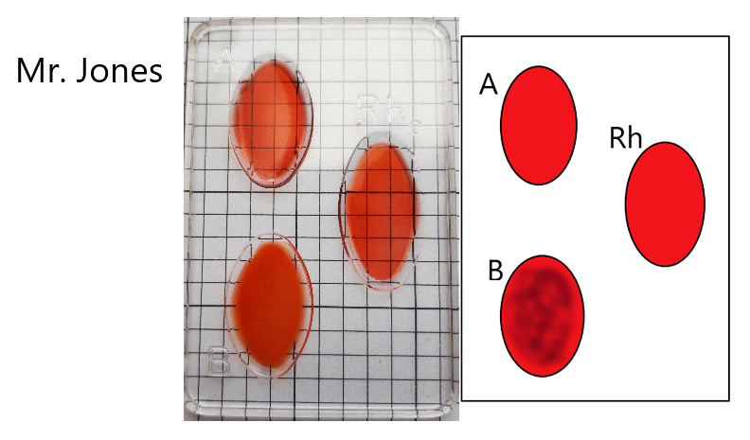

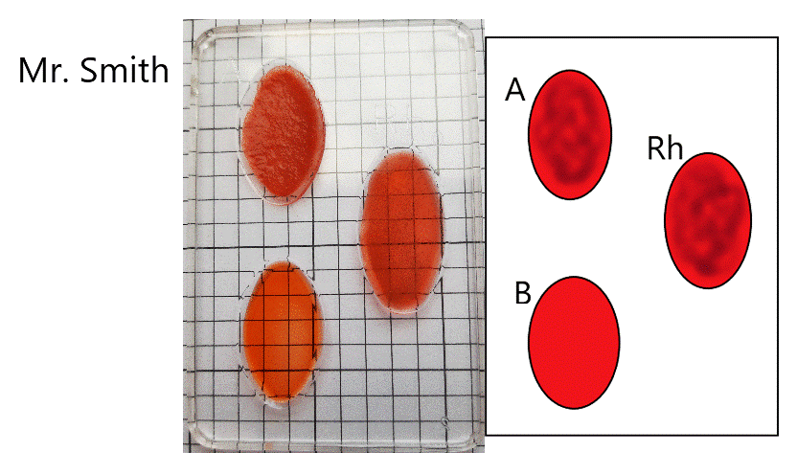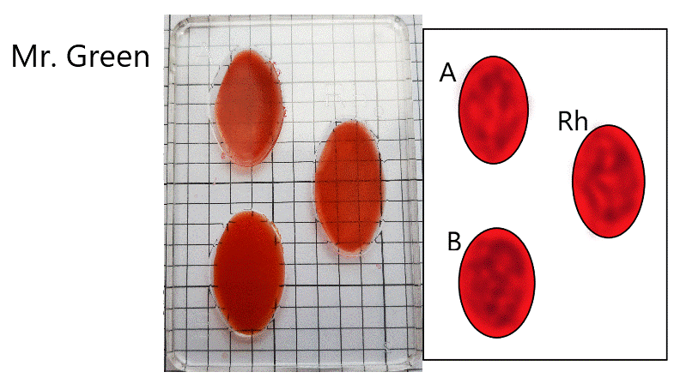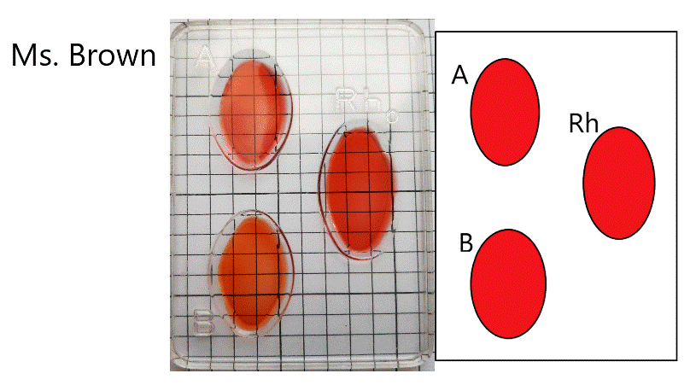

- Mr. Jones receives a blood transfusion from Mr. Smith. What do you expect will happen, and why? Explain, using vocabulary from the introduction. (4 pts)

- If Mr. Green needed a blood transfusion, who should he ask? Please list all acceptable donors, and explain why Mr. Green would be able to tolerate their blood types. (Include all relevant antigens in your explanation.) (3 pts).

- Which blood type alleles are dominant? Which is recessive?

- What is Ms. Brown’s genotype?

- Can you tell the genotype of Mr. Jones and Mr. Smith? Explain why or why not.

- If Ms. Brown and Mr. Green had a baby, what possible blood types could he/she have? Draw a Punnett Square. (Ignore the Rh factor)

- If Mr. Jones and Ms. Brown had 10 children all with type B blood, you can conclude that his genotype is probably _______________. Draw punnett to show your answer.

