Cell Homeostasis Virtual Lab
Guided Question: What happens to a cell when it is in different environments?
To Begin, visit the website below:
https://video.esc4.net/video/assets/Science/Biology/Gateway%20Resources/cell%20homeostasis%20virtual%20lab%20-%20activity/index.html
- Explain how you will conduct this lab to answer the above question:

- Draw and explain what is in each beaker. Be sure to include the sugar solute % in each beaker.
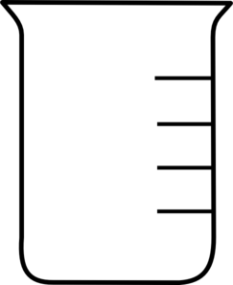
A B C D E

- Why was the petri dish scaled to zero before the sugar was added?

- How many Milliliters of water were added to each beaker? How many grams of sugar were added to each beaker?

- What do the pre-filled dialysis tubes represent?

- Draw and explain what each one is filled with. Be sure to record the mass of each one.

- How long do the dialysis tubes remain in the beakers?

- Record the mass of the dialysis tubes before and after they sat in the beakers for 24 hours.
Before:

After:
Before:

After:
Before:

After:
Before:

After:
Before:

After:

- Calculate the difference in the initial and final masses of each dialysis tube? Create a graph that depicts the behavior of water in different concentrations of sugar solution.

Answer and explain the Questions below:
- Which dialysis tubes had little or no change in mass after a 24-hour period?

- Why was pure water used as a control group?

- Why didn’t the mass of dialysis tubes “A” and “C” change over the 24-hour time frame?

