Cell Cycle Foldable

1) Obtain 3 pieces of white paper and hold them so that each one is slightly lower than the one underneath.

2) Fold the papers so that you now have 6 flaps. Label the flaps: Cell Cycle, Interphase, Prophase, Metaphase, Anaphase, and Telophase/Cytokinesis.

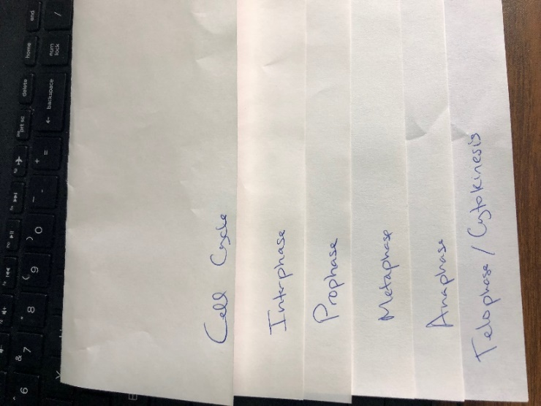

3) Above each phase name, write a description of what is happening during that phase AND include a drawing. Use your notes!!!

