Unit 3: Cell Structure and Function
If all of the DNA in one organism’s cells is the same, why do the cells look different from one another?
Cell Specialization

Introduction
In your last cell lab, you learned the differences between plant and animal cells. There are many types of plant and animal cells. Because plants and animals are multi-cellular organisms, they have specialized cells. A specialized cell has unique characteristics that allow it to perform a specific function in the organism. Cell specialization occurs during development when specific genes are “activated,” or turned on. All cells in one body have the same DNA but since different genes can be switched on and off, the cells can take on different shapes and functions. Both plant and animal cells are modified for specific functions. The size and shape of a cell allows it to perform its function. Also, the number and type of organelles in a cell are related to the cell’s function.

The human body is made up of many millions of individual cells. But these cells are not randomly scattered throughout the body. The body is a well-organized collection of cooperating and communicating cells. Look at the images below. The cells on the left, red blood cells are specialized for transporting oxygen in tiny blood capillaries. The cells in the middle are tightly packed skin cells. The cell on the right is a nerve cell, specialized for quick, effective communication.
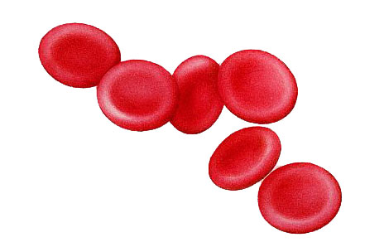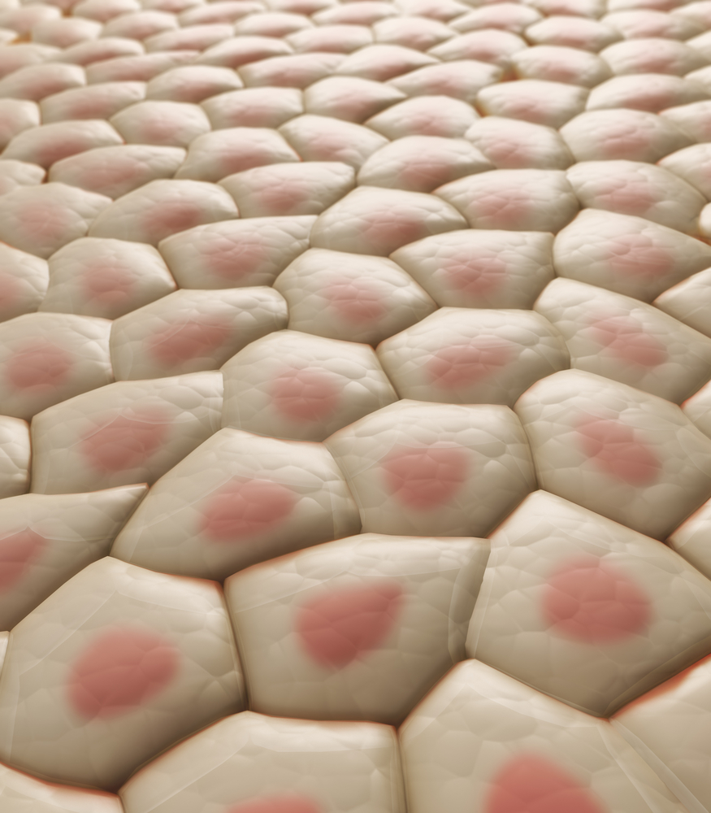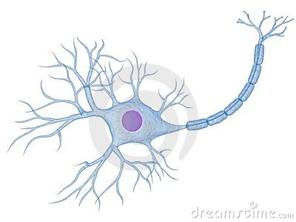

Multicellular organisms are organized in structural levels. Each level builds on the one below it. This organization enables specialization. Cells are specialized to carry out specific functions. A group of cells with related function forms a tissue. The picture of the skin cells above represents a tissue. A group of two or more tissues that carries out a particular function is an organ. Groups of organs form an organ system.

Directions: In this lab you will observe, draw a model, and compare specialized plant and animal cells. You will rotate from station to station. Each table is a station. There may be additional information on the table that helps you answer the questions.

Plant Specialization

- Plant Vascular Tissue: Xylem
- Zea Mays Stem (note in cross section, the xylem is stained pink).
- Label Xylem

Magnification = __________ |  | - What do you notice about the shape of the xylem cells?  _____________________________________________  _____________________________________________  - What is the function of xylem?  _____________________________________________  _____________________________________________  3. How does the shape of this cell help accomplish the function? ______________________________________
Cross sec: | Long sec:

- Plant Storage Tissue: Potato Cells, Stained with Iodine
  - Label Cell Wall
Magnification = ________ | - What is the shape of one potato cell?  _____________________________________________  _____________________________________________  - Estimate the number of leucoplasts (storage sacs) in one cell.  _________________________________________  - Why is iodine a good stain for these cells?  _______________________________________________  - Is this a eukaryotic cell, or a prokaryotic cell?  _____________________________________________

- Plant Cells that specialize in Photosynthesis (Elodea)

Magnification = ________ | - Describe the shape of the Elodea cells?  _____________________________________________  _____________________________________________  - What features do you notice about the chloroplasts?  _____________________________________________  _____________________________________________  - What is the function of a chloroplast?  4. Is this a eukaryotic cell, or a prokaryotic cell?  _____________________________________________
Specialization in Animal Cells: As mentioned above, there are over 200 cell types in the human body. Each of these cells is modified to carry out a specific role.

- Animal Muscle Cells
  - Muscle Types Composite sec.
  - Note that these cells have many nuclei within one cell (multinucleate).

Magnification = ________ | - What is the appearance of a muscle cell?  _____________________________________________  _____________________________________________  - What gives the muscles a striped appearance?  _____________________________________________  _____________________________________________  - What is the function of voluntary muscle cells?  _____________________________________________

- Blood Cells (Red Blood Cell)
- Blood Smear WR stain Human

Magnification = ________ | - What is the shape of a blood cell?  _____________________________________________  - What feature does a red blood cell not have that other eukaryotic cells do have?  _____________________________________________  - What is the function of red blood cells?  _____________________________________________  _____________________________________________

- Sperm Cells
- Sperm smear
- Note: these cells are smaller than most cells you have seen. View under high power.
Magnification = ________ | - What cell structure is found in a sperm that is not found in other body cells?  _____________________________________________  _____________________________________________  - Describe the size and shape of the sperm cell?  _____________________________________________  _____________________________________________  - What is the function of this structure?  _____________________________________________  - What is the function of sperm?  _____________________________________________  _____________________________________________

- Nerve Cells (neuron)
- Motor nerve ending and plates
- Note the dark purple is nerve tissue (many cells) and the light purple is muscle tissue.

Magnification = ________ | - Describe the shape of the cell in this slide?  _____________________________________________  _____________________________________________  - What feature of nerve cells allows them to transmit signals to other cells?  _____________________________________________  _____________________________________________  - Where are nerve cells found?  _____________________________________________  _____________________________________________

