Cellular Respiration Guided Notes

4 Types of Energy:
1)
2)
3)
4)

ATP
1) The long name for ATP is _____________________ ___________________________.
2) ATP is like a ____________________ _________________________.
3) When the energy from ATP is used, it becomes ______________.
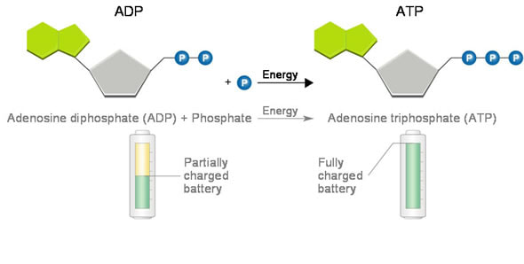
All of the energy used to make ATP comes from __________________.

Cellular Respiration
1) Main Objective of Cellular respiration (What does it do?):
2) Equation for Cellular Respiration using words:

3) Equation for Cellular Respiration using Chemical Formulas:

4) Cellular Respiration that uses oxygen is called _____________________, while cellular respiration that does not use oxygen is called _______________________.

Aerobic Respiration Happens in the ________________________
Label the inner membrane, outer membrane, cristae, and matrix

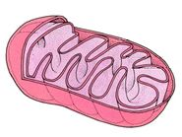

Main Steps Aerobic Respiration
1)

2)

3)

Glycolysis
- first step in cellular respiration, does not require __________________
Main Objective:

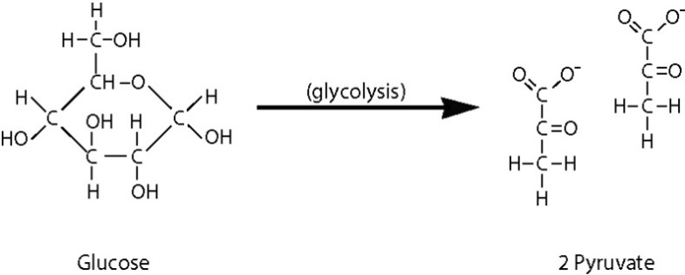
Location:

Reactants:

Products:

Intermediate Reaction: converts ___________ to __________________.
Requires _______________________!!!!

Kreb’s Cycle
Requires _______________________!!!!
Main Objective:

Location:

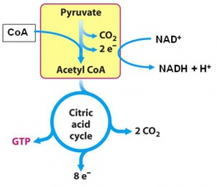
Reactants:

Products:

Electron Transport Chain
Requires _______________________!!!!

Main Objective:

Location:

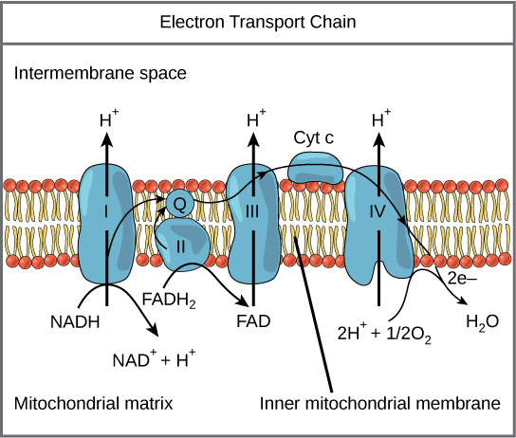
Reactants:

Products:

ATP Totals
Reaction | Number of ATPs Produced

Anaerobic Respiration
1) Doesn’t require ___________________________
2) Two Main Types
1)

2)

3) Both start with ___________________________.
4) Fermentation:

Lactic Acid Fermentation
1) Organisms that do lactic acid fermentation:
2) Steps:
1)

2)

3) Main byproduct of lactic acid fermentation:

4) Example:

Alcoholic Fermentation
1) Organisms that do alcoholic fermentation:
2) Steps:
1)

2)

3) Main byproduct of alcoholic fermentation:

4) Example:

