Ecology Notes

Introduction to Biology

Biology-

Characteristics of living things:

1)

2)

3)

4)

5)

6)

7)

8)

Ecology

Ecology-

habitat-

Ecology Levels of Organization

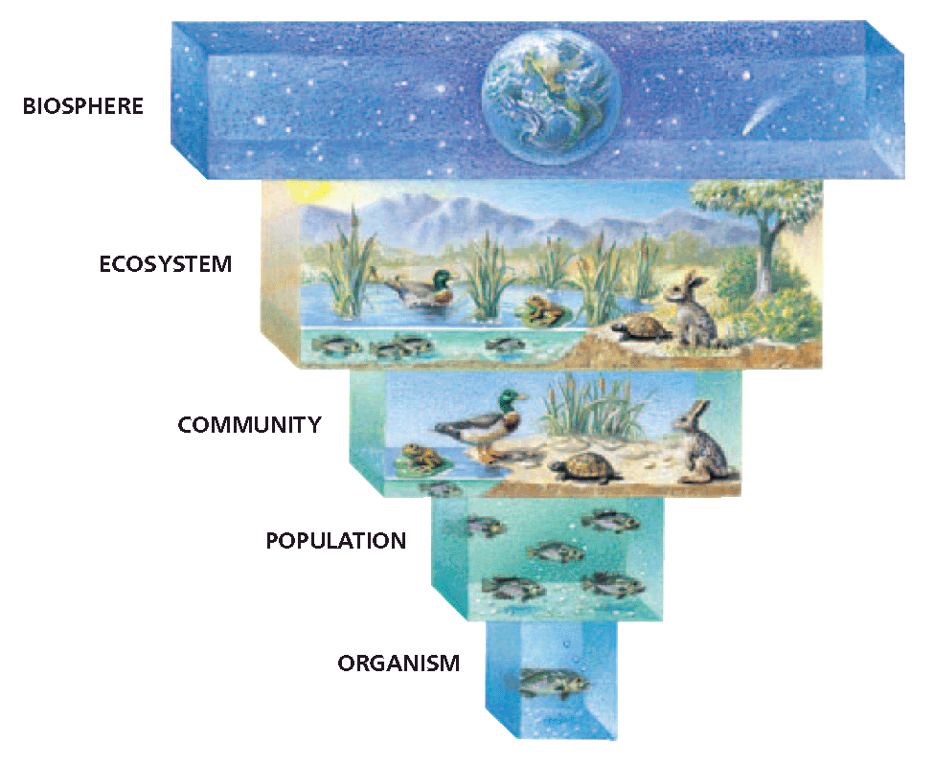
population-

community-

ecosystem-

A) abiotic factors-

Example-

B) biotic factors-

Example

biodiversity-

biosphere-

Energy Flow in an Ecosystem

niche-

primary productivity-
producers-

Also known as __________________________

consumers-

Also known as __________________________

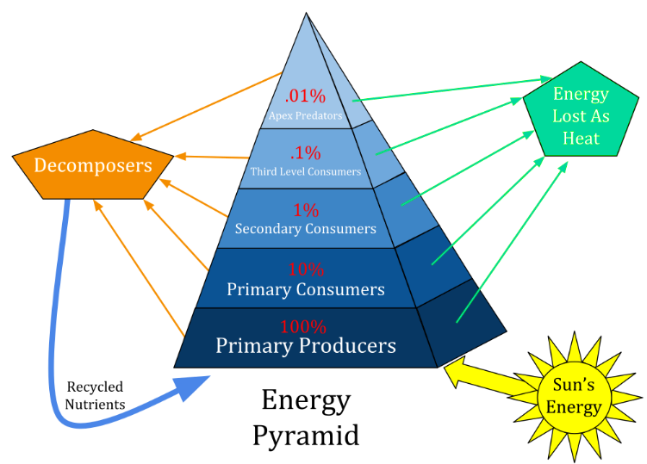
detritivores-

Energy Pyramids

What is shown by an energy pyramid?

trophic level-

How much energy is lost at each trophic level?

1st level- ___________________________

2nd level- primary consumers
-__________________________ (animals that eat plants or other producers)

3rd level- secondary consumers
-_________________________ (animals that eat meat)
- _________________________ (animals that are herbivores and carnivores)

4th level- tertiary consumers (carnivores that consume other carnivores)

*** At all levels are the ____________________________ (organisms that obtain their energy from organic wastes and dead bodies. Some are called decomposers because they cause decay.

Keystone species-

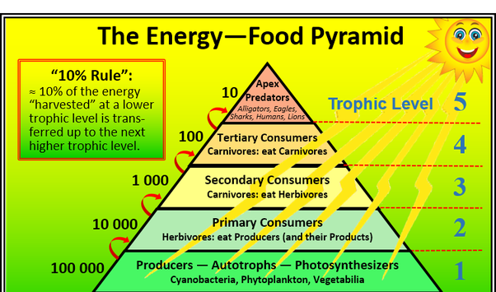

Interactions Between Species

Symbiotic Relationship-

Interaction | Species A | Species B | My Example | Your Example

How do ecosystems form?

Succession-

A) primary succession-

Example:

B) secondary succession-

Example:
