Ecology Notes

1) ecology-

2) habitat-

Ecology Levels of Organization

3) population-

4) community-

5) ecosystem-
A) abiotic factors-

Example-

B) biotic factors-

Example-

6) biodiversity-

Energy Flow in an Ecosystem

7) niche-

8) primary productivity-

9) producers-

10) consumers-

11) detritivores-

12) trophic level-

13) How much energy is lost at each trophic level?

14) Food chain- path of energy through the trophic levels

1st level- ___________________________

2nd level- primary consumers
-__________________________ (animals that eat plants or other producers)

3rd level- secondary consumers
-_________________________ (animals that eat meat)
- _________________________ (animals that are herbivores and carnivores)

4th level- tertiary consumers (carnivores that consume other carnivores)

*** At all levels are the ____________________________ (organisms that obtain their energy from organic wastes and dead bodies. Some are called decomposers because they cause decay.

15) Keystone species-

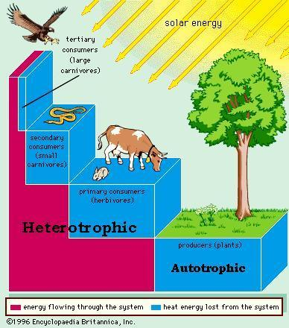

Interactions Between Species

Interaction | Species A | Species B | Description

How do ecosystems form?

14) _________________________- the somewhat regular progression of species replacement
A) primary succession-

Example: receding glacier

B) secondary succession-

Example: abandoned fields or forest clearings
