Biology 102, Spring 2020
ACCESS EXAM 3

You must know the following for all systems we covered:
1) Function
2) Anatomy (Be able to label diagrams)

Animal Physiology

1) Function of each type of tissue
2) Which of these is an example of positive feedback?
Ectotherms vs endotherms

Digestive System
1)Know the digestion activity chart and function of all enzymes
2) Bile
3) Function of stomach acid
4)Celiac disease
5) Peristalsis
6) Where is most liquid absorbed?
7) Product of breakdown of each type of macromolecule

Circulatory System
1) Order of blood flow
2) hematocrit and diarrhea
3) sounds and heart valves
4) lymphatic disorders
5) o2 concentration and pressure of major blood vessels
6) Heart structure
7) Function of veins
8) What blood pressure readings are measuring (systolic and diastolic)
9) Name valves
10) Capillary structure
11) Pace makers and electrical activity
12) anemia
13) Cardiovascular system diseases
14) hemoglobin
15) Function of capillaries
16) Characteristics of maternal hemoglobin
17) Acclimation to high altitudes

Respiratory System
1) What muscular movements cause the air to be drawn into the lungs?
2) The air passageway structure
3) Partial pressure and its effect on diffusion
4) Pick the correct sequence of the pathway of air through respiratory system
5) Which one of the following is NOT a function of respiratory system?

Know the role of smooth muscle in each system!!

Figure 1 Figure 2
9

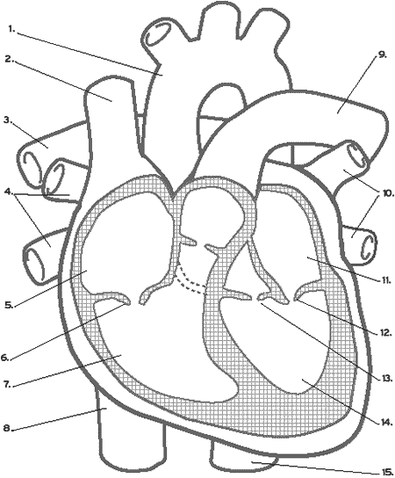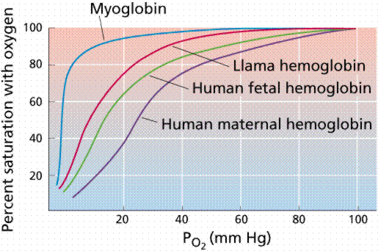

Figure 3

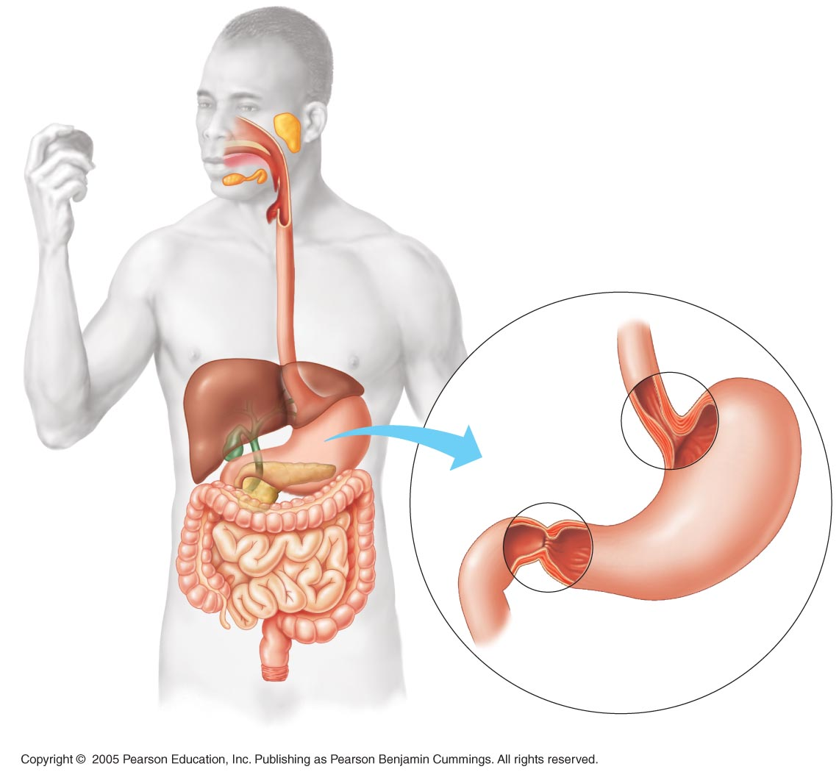

Peptidase
Trypsin
Pepsin

Protein Polypeptides small peptides amino acid

