Gene Regulation Video Worksheet

Gene Regulation and the Order of the Operon
https://www.youtube.com/watch?v=h_1QLdtF8d0

1. DNA is used to give ____________________________ during the process of protein synthesis.

2. Gene regulation will determine which genes to turn on and when, for example –

Regulatory Proteins for:

a) positive transcription to __________________________ the rate of transcription

b) negative transcription to __________________________ the rate of transcription

3. __________________________ are molecules that build up, break down and speed of chemical reactions.

4. There are four key players in “Operon” gene regulation.

 | It’s a builder enzyme & starts transcription
 | Section of DNA that binds to RNA polymerase
Operator | Section of DNA that contains the _____________ to be __________________________
 | Can bind to the operator and stop RNA polymerase

Regulation of Gene Expression
https://www.youtube.com/watch?v=J9jhg90A7Lw

1. Transcription and translation serve as a code for the ____________________________ of everything
within that organism

2. Some polypeptides will undergo folding in the ____________________ ___________ and sometimes
modification will occur in the _______________________ _________________________ where special groups
like sugars, lipids and phosphates are attached.

3. Complete the “Central Dogma of Molecular Biology” below:

______________ → _______________ → ___________________________

4. Every somatic cell in your body contains the exact copy all of your genetic information, but
different cells in your body serve ____________________________________ purposes and need to
_______________________________ different genes.

5. _____________________________ mechanisms result in selective gene expression that should reflect the
immediate chemical surroundings

6. If a substance surrounding a cell is ______________________________ the cell will ____________ producing
that substances, if it is _______________________ the cell will kick ____________________ the production to
survive (feedback inhibition)

7. The operator (which is like an _________/___________ switch) is a small section of DNA that controls
whether RNA polymerase has access to transcribe or not.

8. Most genes are typically _________ unless repressed, however some genes are ___________ unless activated.

9. Explain two examples of negative gene expression:

- A molecule ___________________________ repression of a gene

- A molecule ___________________________ repression

10. Explain positive gene regulation:

- a ________________________ molecule generates a complex that ______________________ with DNA

11. Genes bound to ____________________________ cannot be expressed because RNA polymerase
cannot access them

12. A _____________________ box (a transcription factor) is a region of DNA that is easy to pry apart and
can easily initiate transcription.

13. Certain signaling molecules may only be present during _______________________ __________________
in the life cycle, like during puberty.
Production of Proteins Name: ___________________________________
Video Reflection

What is a Gene?
https://www.youtube.com/watch?v=5MQdXjRPHmQ&t=183s

1. Each one of our cells contains ___46___ strands of DNA. A single strand is made of millions of
particles called ____NUCLEOTIDES______.

2. A _____GENE_____ is a special stretch of DNA, a ___SEQUENCE______ of A’s, T’s, C’s
and G’s that codes for something.

3. Genes make ____PROTEINS_____, that interact with each other proteins.

4. A single strand of DNA contains thousands of genes or unique protein ____RECIPES____.

5. Human have approximately __20,000___ genes all together.

6. The size and shape of the gene will determine the ___SIZE____ and __SHAPE_____
of the protein which will determine the function of that protein in the body.

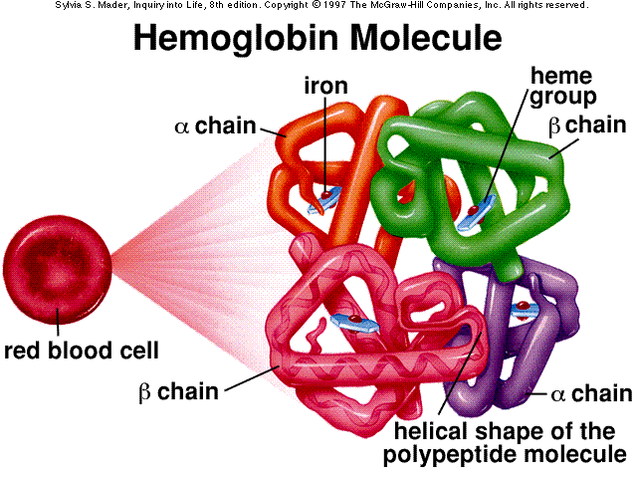
7. Draw a picture and explain the function of the hemoglobin protein.

Hemoglobin is a red blood cell protein
That can carry 4 oxygen molecules

8. What happens when a gene from bacteria is placed in a plant or an animal?

The plant or the animal will begin making the bacterial protein

9. Explain some interesting examples of how scientists have manipulated genetics.

corn that is toxic to insects, tomatoes that stay fresh longer
Bacteria that makes insulin

Protein Synthesis
https://www.youtube.com/watch?v=oefAI2x2CQM

1. Proteins serve several different important roles or functions. Identify at least 4.

1 Transport 2 Structure

3 Enzymes 4 Protecting the Body

2. ____TRANSCRIPTION___ and ___TRANSLATION____ are the two major steps in
protein synthesis.

3. Transcription occurs in the ___NUCLEUS_____ where RNA polymerase will connect
complimentary RNA __BASES____ to the DNA to make single stranded __mRNA___ or
messenger RNA.

4. mRNA will leave the nucleus and enter the cytoplasm to attach to a ___RIBOSOME_______
to make proteins during translation.

5. ___tRNA___ (transfer RNA) carry an ___AMINO___ __ACID___ on them with the monomer
for a protein or a building block for ___PROTEIN_____.

6. mRNA ____CODON_____ and tRNA ____ANITCODON______ come in 3-base complimentary
pairs. Each codon will correspond to a unique or specific amino acid. For example, AUG or
methionine is a ____START______ codon.

Why RNA Is Just As Cool as DNA
https://www.youtube.com/watch?v=0Elo-zX1k8M

1. Without ___RNA____ you wouldn’t be able to get genetic message out to cells to
produce ____PROTEINS_____.

2. DNA and RNA are both _____NUCLEIC______ acids

3. Compare and Contrast DNA and RNA.

DNA | RNA
____DEOXYRIBOSE____ sugar | ___RIBOSE____ sugar
______DOUBLE____ stranded | __SINGLE_____ stranded
Adenine, Guanine, Cytosine & __THYMINE___ | Adenine, Guanine, Cytosine, __URACIL____
Found in the ___NUCLEUS_____ | In the _NUCLEUS____ & the __CYTOPLASM_____
 | 3 types of RNA: mRNA, tRNA, rRNA

Gene Regulation and the Order of the Operon
https://www.youtube.com/watch?v=h_1QLdtF8d0

1. DNA is used to give ___INSTRUCTIONS____ during the process of protein synthesis.

2. Gene regulation will determine which genes to turn on and when, for example –

Regulatory Proteins for:

a) positive transcription to ___INCREASE______ the rate of transcription

b) negative transcription to ___DECREASE_____ the rate of transcription

3. ____ENZYMES_____ are molecules that build up, break down and speed of chemical reactions.

4. There are four key players in “Operon” gene regulation.

RNA polymerase | It’s a builder enzyme & starts transcription
Promoter | Section of DNA that binds to RNA polymerase
Operator | Section of DNA that contains the _____________ to be __________________________
Repressor | Can bind to the operator and stop RNA polymerase

Regulation of Gene Expression
https://www.youtube.com/watch?v=J9jhg90A7Lw

1. Transcription and translation serve as a code for the __MANUFACTURE______ of everything
within that organism

2. Some polypeptides will undergo folding in the ____ROUGH_____ ___ER___ and sometimes
modification will occur in the ____GOLGI_____ __APPARATUS_____ where special groups
like sugars, lipids and phosphates are attached.

3. Complete the “Central Dogma of Molecular Biology” below:

___DNA___ → ___RNA____ → ____PROTEINS____

4. Every somatic cell in your body contains the exact copy all of your genetic information, but
different cells in your body serve ____DIFFERENT______ purposes and need to
___EXPRESS____ different genes.

5. ____REGULATORY____ mechanisms result in selective gene expression that should reflect the
immediate chemical surroundings

6. If a substance surrounding a cell is ____PLENTIFUL_____ the cell will __STOP___ producing
that substances, if it is ___SPARCE______ the cell will kick ___START____ the production to
survive (feedback inhibition)

7. The operator (which is like an __ON___/__OFF___ switch) is a small section of DNA that controls
whether RNA polymerase has access to transcribe or not.

8. Most genes are typically __ON__ unless repressed, however some genes are __OFF__ unless activated.

9. Explain two examples of negative gene expression:

- A molecule __ACTIVATES____ repression of a gene

- A molecule __DEACTIVATES____ repression

10. Explain positive gene regulation:

- a ____SIGNALING____ molecule generates a complex that ___INTERACTS___ with DNA

11. Genes bound to ____HISTONES____ cannot be expressed because RNA polymerase
cannot access them

12. A ___TATA___ box (a transcription factor) is a region of DNA that is easy to pry apart and
can easily initiate transcription.

13. Certain signaling molecules may only be present during __SPECIFIC___ ___TIMES___
in the life cycle, like during puberty.

