Homework #2

Format: Type or write clearly

WARNING: You must put your answers on this worksheet. Do not answer on a separate sheet of paper.

*Identify the components of the following experiment.*

Long ago, many people believed that living things could come from nonliving things. They thought that worms came from wood and that maggots came from decaying meat. This idea was called spontaneous generation. In 1668, an Italian biologist, Francesco Redi, did experiments to show that maggots did not come from meat. One of his experiments is shown below.

Group II



Group I

Redi placed pieces of meat in several jars. He divided the jars into two groups. He covered the first group of jars with fine cloth. He left the second group of jars uncovered. Redi observed the jars for several days. He saw flies on the cloth of the covered jars, and he saw flies laying eggs on the meat in the uncovered jars. Maggots appeared only on the meat in the group of jars left uncovered.

1. Circle the hypothesis in the explanation above.

2. Identify the replication and total sample size.

Replication = Total sample size =

3. Identify the independent variable.

4. Identify the dependent variable.

5. Which group is the control? Explain.

6. What do you think Redi’s conclusion was?

a. Living things come from other living things.

b. Living things are created through spontaneous generation.

c. He did not have enough data to arrive at a conclusion.

*Identify the independent and dependent variables and control for the following experiments.*

7. Stephen predicted that seeds would start to grow faster if an electric current traveled through the soil in which they were planted.

Independent variable =

Dependent variable =

Control =

8. Rene grew bacteria from the mouth on special plates in the laboratory. She placed drops of different mouthwashes on bacteria on each plate.

Independent variable =

Dependent variable =

Why would water be an appropriate control for this study?

9. Kim’s experiment showed that chicken eggshells were stronger when she gave the hen feed to which extra calcium had been added.

Independent variable =

Dependent variable =

Control =

10.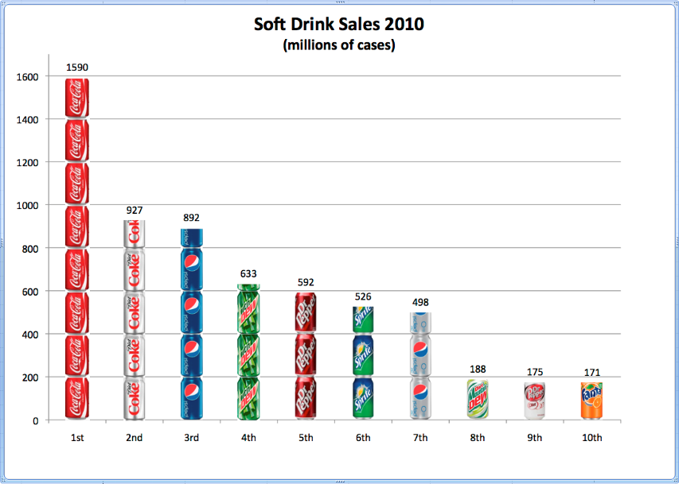 Independent variable =

Dependent variable =

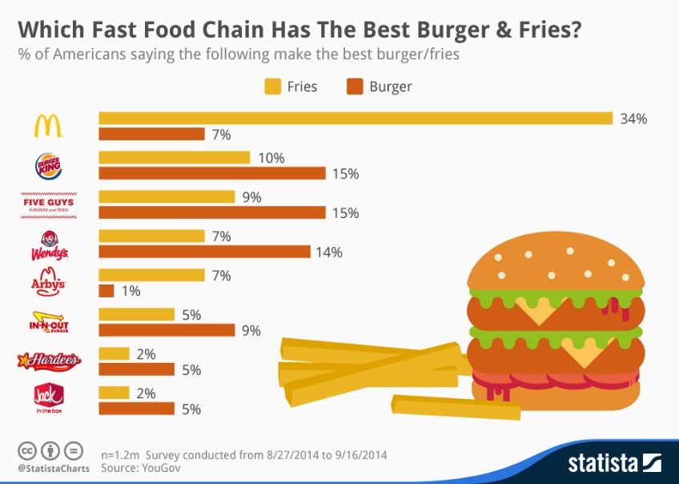11. Independent variable =

Dependent variable =