Homework #8
Format: Type or write clearly
WARNING: You must put your answers on this worksheet. Do not answer on a
separate sheet of paper.
1. Label the name of each process in the ovals on the diagram below.

2. Label the diagram using each of the following terms once. Use these terms to fill in the rectangular boxes:
Codon Ribosome
DNA mRNA (use twice)
Nucleus Amino acid
Anti-codon RNA polymerase
Nuclear pore tRNA
Protein

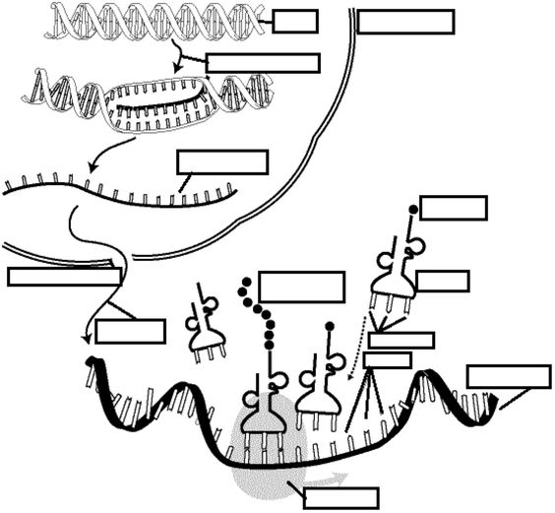

3. Complete the following table
DNA | mRNA | tRNA | Amino Acid
A
T
A
C
A
G
G
G
C
T
A
A

4. In the table above, name the column that contains the codons.

5. In the table above, name the column that you used to determine the amino acid sequence.

6. In the table above, name the column that contains the gene.

7. In the table above, name the column that is the product of transcription.

8. How many codons are present in the gene sequence above?

9. Is this the beginning, end or middle of the protein? How do you know?

