How do biological organisms use energy?

The Importance of ATP
Living organisms use a two-step process to provide the energy needed for most biological processes.

I. First, cellular respiration makes ATP from ADP plus a phosphate (P). The energy for this chemical reaction is provided by the cellular respiration of sugars or other organic molecules.

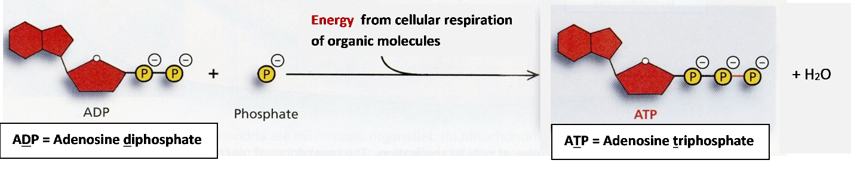
II. Then, the hydrolysis of ATP provides the energy for most biological processes. When ATP and water react to form ADP plus a phosphate, this reaction provides the energy for many different cellular processes.

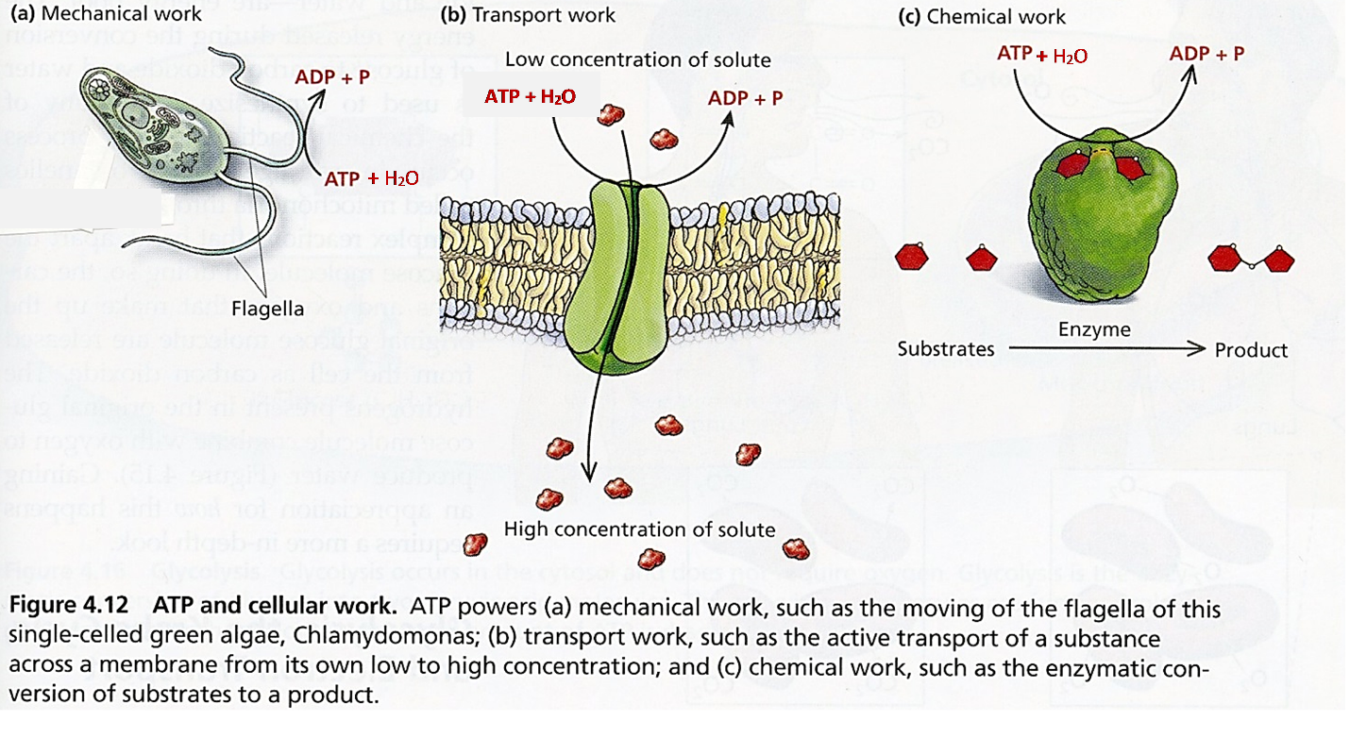

Notice that the role of ATP in biological organisms is somewhat similar to the role of money in our society. Most people use a two-step process to get food, clothing, etc.

I | Cellular respiration makes ATP, using energy  from the cellular respiration of sugars or  other organic molecules. | Most people work to earn money.
II | Then, the hydrolysis of ATP provides the  energy for most biological processes. | Then people spend their money to buy the things they need or want.

1. Give one reason why the reaction, ADP + P ATP + H₂O, requires energy input. (Hint: Notice the charges of the molecules in the top figure.)

2a. Inside each cell, there is a constant cycle of synthesis and breakdown of ATP. Label the diagram to show:
- Cellular Respiration
- Use of energy

2b. Explain why a cell needs to constantly break down and synthesize ATP.

I. Cellular Respiration
The chemical equations shown below summarize the cellular respiration of glucose (a simple sugar). Glucose and oxygen are the inputs for a series of chemical reactions which produce carbon dioxide and water, and provide the energy to make ATP from ADP + P. The actual process of cellular respiration in cells requires many steps which are not shown here.

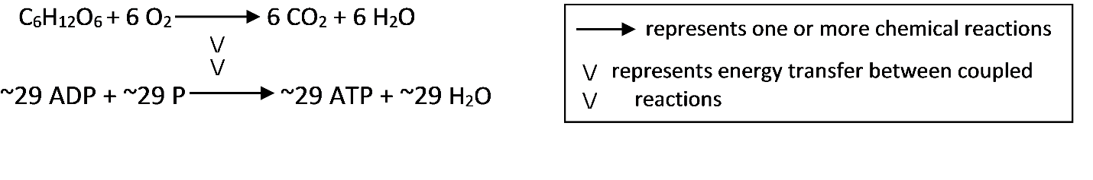
3. Write the names of each of the molecules in these chemical equations.

4. How do our bodies get glucose and other organic molecules for cellular respiration?

5. Why do we need to breathe all day and all night?

6a. If you search for "cellular respiration equation" on the web, some of the most popular sites give the following chemical equation for cellular respiration of glucose.
C₆H₁₂O₆ + 6 O₂ 6 CO₂ + 6 H₂O + ATP

What is wrong with this chemical equation? (Hint: Think about where the atoms in an ATP molecule come from.)

6b. Write a corrected version of this chemical equation that gives a more accurate summary of cellular respiration. (Hint: This corrected chemical equation should combine the two coupled reactions shown in the middle of this page.)

II. Using ATP to Provide Energy for Biological Processes
As shown on page 1, the hydrolysis of ATP provides the energy for many biological processes, including mechanical work, pumping ions into or out of the cell, and synthesizing molecules.

7. The chemical equation for the hydrolysis of ATP is
- ADP + H₂O → ATP + P
- ADP + P → ATP + H₂O
- ATP + H₂O → ADP + P
- ATP + P → ADP + H₂O

8. Which is high energy: ATP or ADP?

9. The reaction, ATP + H₂O → ADP + P occurs:
- only in muscle cells
- in muscle cells and nerve cells
- in all the cells in your body.
What reasoning supports the answer you chose?

Two important general principles about energy are:
- Energy can be transformed from one type to another (e.g. chemical energy can be transformed to the kinetic energy of muscle contraction). However, energy can not be created or destroyed by biological processes.
- All types of energy transformation are inefficient. For example, the energy for muscle contraction is provided by the hydrolysis of ATP, but only about 20-25% of the energy from this chemical reaction is captured in the kinetic energy of muscle contraction. The rest of the energy is converted to heat.

10. Cellular respiration takes place primarily in organelles called mitochondria. Some textbooks claim that "Mitochondria make the energy needed for biological processes." Explain what is wrong with this sentence and give a more accurate sentence.

11. Explain why your body gets warmer when you are physically active.

By Dr. Ingrid Waldron, University of Pennsylvania, 2016. Teachers are encouraged to copy this Student Handout for classroom use. A Word file (which can be used to prepare a modified version if desired), Teacher Notes with instructional suggestions, background information and alignment with Next Generation Science Standards are available at http://serendip.brynmawr.edu/exchange/bioactivities/energy.

