Introduction Foldable

1) Fold a legal size envelope in half and cut around one side to make 2 pages on the left and a pocket on the right.

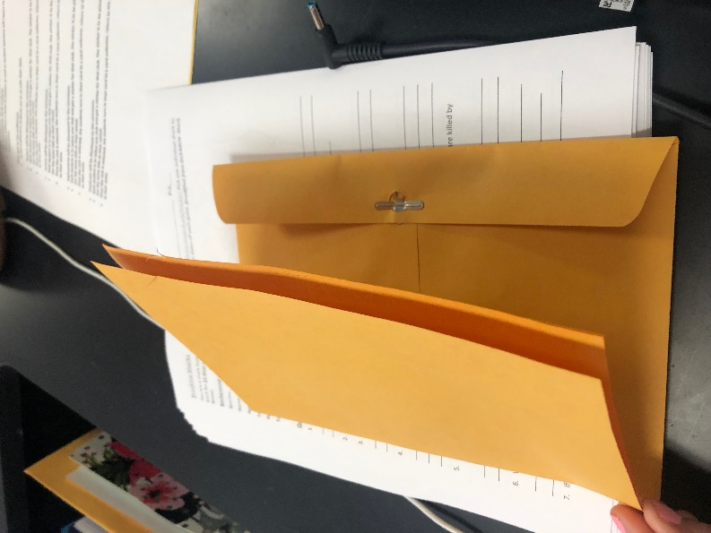

cover

2) Fold a sheet of paper glue it down on the cover of the booklet. Write “Characteristics of Living Things” on the front and write the 7 characteristics of living things on the inside.

3) Hold 3 pieces of white paper so that each one is slightly lower than the one underneath.

4) Fold the papers so that you now have 6 flaps. After trimming to fit inside the booklet, glue onto the back of the front page. Label the flaps: Question, Research, Hypothesis, Experiment, Results, and Conclusion.

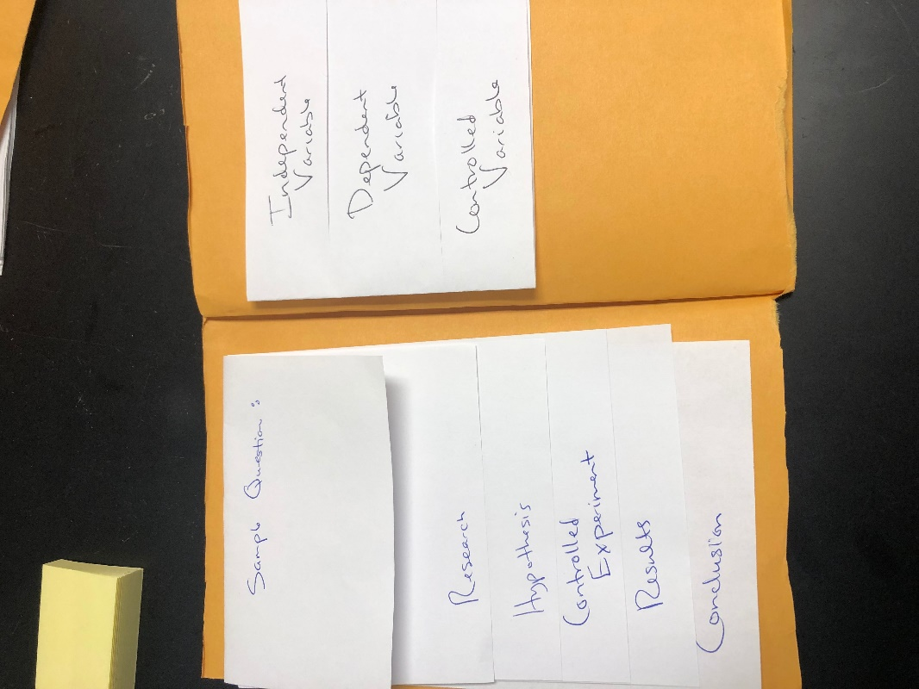

5) Write your sample research question (from study guide) on the front of the top flap. Lift the top flap and write what you might research to answer that question above where you have written “Research”. Lift the research flap and write an example hypothesis for your question above where you have written “Hypothesis”. Lift the hypothesis flap and write out an example experimental procedure above where you have written “Experiment”. Label independent and dependent variables. Lift the Experiment flap and draw a sample graph for your experiment above where you have written “Results”. Lift the results tab and write an example conclusion above where you have written “Conclusion”.

6) Fold a half sheet of paper and glue into page opposite the scientific method flaps. Cut so you have 3 flaps and label them:
“Independent Variable”
“Dependent Variable”
“Controlled Variable”
Write the definition of each inside the flap

7) Fold a half sheet of paper and glue into the next page. Cut so you have 3 flaps and label them:
“Bar Graph”
“Line Graph”
“Pie Chart”
Write the definition of each inside the flap

8) Fold a half sheet of paper and glue into the next page. Cut so you have 2 flaps and label them:
“Hypothesis”
“Scientific Theory”

