Macromolecule Notes

What are macromolecules?

Types we will learn:
1)
2)
3)
4)

Carbon (most important element in macromolecules!!)
Why can carbon form the backbone of biological molecules?
1)

2)

3)

Double bond-

Triple bond-

Monomers and Polymers

Polymer-

Monomer-

Other examples of monomers and polymers:

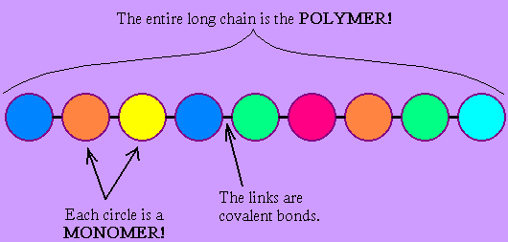

List the 4 Types of Macromolecules

1)
2)
3)
4)

