Love Flirting, and Death in the Muscle Lab: Muscle Types, Structure, and Fatigue
Graded out of 23pts
*Note – Due to the data being provided to you the point values of some questions have been changed. Changes are indicated with red text.*
Watch the video at the following link for an overview of the 3 muscle types. https://youtu.be/Fyqj_9eiC_Q
Use the information from the video to identify characteristics of each muscle type
Table 1. Characteristics of Types of Muscle Tissues (1 pt)
Muscle Tissue Type | Voluntary or Involuntary | Cell Characteristics (shape, branching, striation) | Act as unit or separate cells? | Controlled by nervous/endocrine system?
Cardiac | Involuntary |  | Single unit | Nervous
Smooth | Involuntary |  | Single unit | Nervous and endocrine
Skeletal | Voluntary |  | Separate cells | Nervous

Part 1: Drawings
Skeletal Muscle (2 pts)
- Label the image
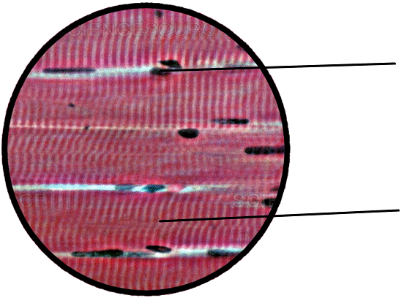
Total magnification:_________ (i.e., you would use the highest magnification)

Cardiac Muscle (2 pts)
- Label the image
Total magnification: ___________ (i.e., you would use the highest magnification)
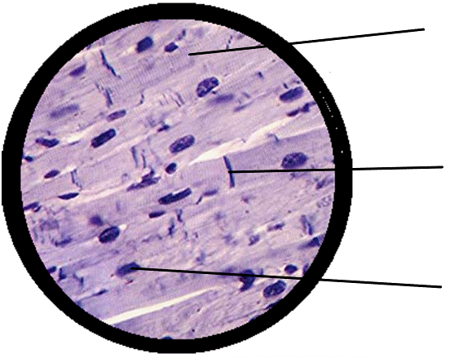

Smooth Muscle (2 pts)
- Label the image
Total magnification: ___________ (i.e., you would use the highest magnification)
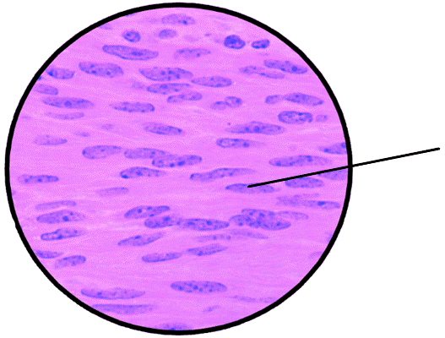

Part 2

Table 2 Hand Fatigue Test Data
Trial | Number of Tennis Ball Squeezes | Mean Force (N)
1 |  | 69
2 | 186 | 56
3 | 171 | 50
4 | 155 | 42

- For each of the three types of muscle cells, choose a structural feature unique to that type, and explain how it suits the function of that cell. (4 pts)
Cardiac -

Skeletal -

Smooth -
- Consider your data from Part 2 that you recorded in Table 2. Was the test subject able to keep the same mean force for all four trials? Explain. Cite your data (3 pts)

- If fatigue occurred, what substances were probably building up in the muscles during Part 2, and why? (3 pts)

- Explain how fatigue protects cells. (3 pts)

- What kind of metabolism was mainly used to provide energy for the contractions in Part 2? Explain your reasoning. (3 pts)

