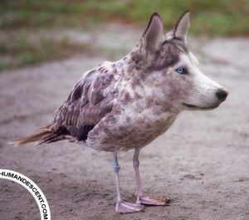
Mutation Notes
1) Objectives for this section:
1)
2)
3)
2) mutation-
3) 2 main types of mutations- list and define
1)
2)

Point Mutations
4) Types of Point Mutations (NAME and DEFINE)
1)
2)
3)
4)
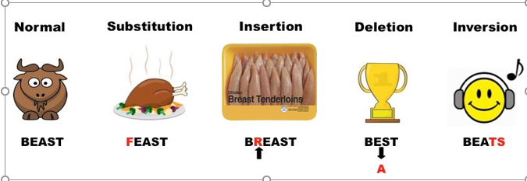

5) What is a frameshift? How does it affect the protein that gets made?

6) What is sickle cell anemia?
7) What protein is misshapen in sickle cell anemia?
8) What type of mutation causes this protein to be shaped incorrectly?

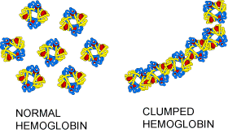
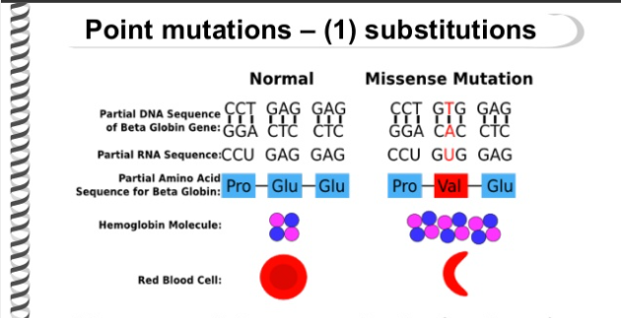

9) What was the answer to the first mutation practice problem in the video lecture? List which nucleotides were added, deleted, or substituted.

10) What was the answer to the second mutation practice problem in the video lecture? List which nucleotides were added, deleted, or substituted.
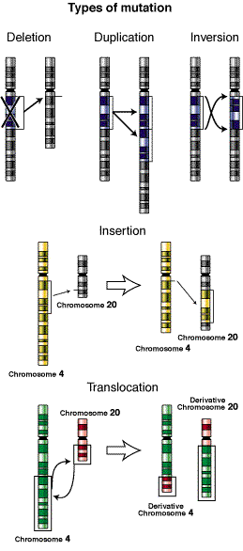
Chromosomal Mutations
11) What are chromosomal mutations?
12) List and Define the types of chromosomal mutations.
1)
2)
3)
4)
5)
13) What is a karyotype?
14) How many of each type of chromosomes does a body cell have (not eggs or sperm)?
15) The karyotype in the video showed a person with ________________ __________________.

