Photosynthesis Guided Notes

Photosynthesis-

3 Reasons Photosynthesis is important:
1)

2)

3)

Chemical equation for photosynthesis:

Location for Photosynthesis:

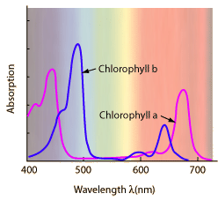
Chlorophyll-

Wavelengths (colors) of light chlorophyll absorbs:

2 Main Parts of Photosynthesis:
1)

2)

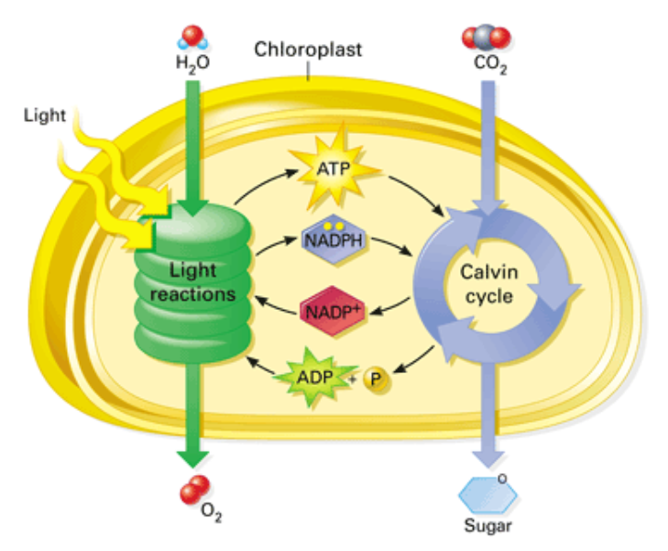

Light Reactions
The main objective of light reactions is to:

Main players in the light reactions:
Photosystem-

Electron Transport Chain-

ATP Synthase-

Summary of Light Reactions
Reactants:

Products:

Location:

Dark Reactions
The main objective of light reactions is to:

Reactants:

Products:

Location:

Factors That Affect Photosynthesis
1)

2)

Factors That Affect Photosynthesis (Continued)
3)

