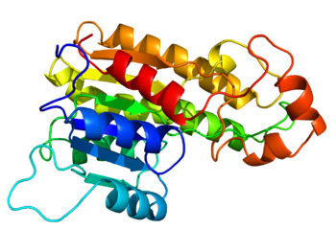
Protein Profile Project

Earlier in this course, we learned that proteins play a major role in the functioning of cells and have a diverse range of functions including fighting disease, catalyzing chemical reactions, and forming complex structures in living organisms. A protein is a very long string of amino acids, the order of which is determined by the sequence of bases in the gene that codes for it. A gene, in turn, is a stretch of DNA that contains the recipe for making one protein.
Although every cell in a multicellular organism contains the exact same genetic information (DNA), a cell produces only those proteins needed for its particular function. We say these cells are “specialized” for a specific role in the organism. In the Cell Specialization Lab, we viewed different cell types under the microscope and compared their structure to function (what they do). Some examples of specialized cells important for humans are muscle, nervous, and blood cells. Some specialized cells in plants include xylem, phloem, and guard cells.
In this activity, we will take a closer look at the proteins produced by each of these cell types to see how they influence the shape and function of these specialized cells. You will choose one protein from the list below to study. Each of these proteins was featured as a “Molecule of the Month” on the RSCB Protein Data Bank website, which you will use along with other online sources to fill out a Fact Sheet about your protein. When finished, this information will be used to construct both a poster on your protein and a 3D model of its structure.

Protein List

1) Actin
2) Myosin
3) Hemoglobin
4) Thrombin
5) Rubisco
6) Insulin
7) Collagen
8) Keratin
9) Myelin Basic protein
10) EPSP Synthase “Round up Ready”
11) Ricin
12) Prions
13) Voltage Gated Sodium Channels
14) Nuclear Pore Complex
15) Serotonin Receptor
16) Opiod receptor
17) Luciferase
18) p53 Tumor Suppressor
19) Antibody
20) Coronavirus Protease

Protein Profile Fact Sheet

Protein Name:
Function (role in the cell):

Organisms it is found in:

Type of cells that produce it:

Other proteins it interacts with:

Length of gene that codes for it:
Location of gene (Chromosome Number):
Number of amino acids:

Overall 3D shape (describe and draw a sketch):

What happens if the protein is missing or misshapen?

Diseases that involve this protein:

Known mutations:

